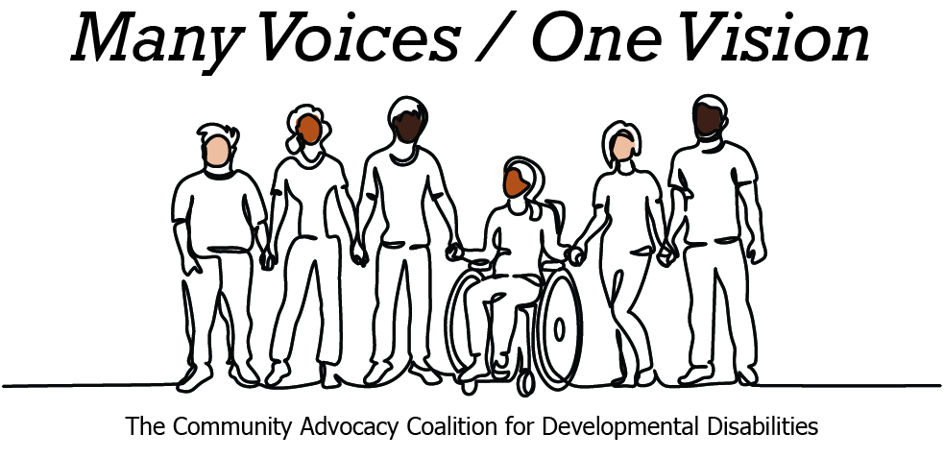 | 

2026 Legislative Candidate Survey
Questions for Legislative Candidates — The Arc of Washington
The Community Advocacy Coalition for Developmental Disabilities
The Children’s Campaign Fund

Name: Vanessa Kritzer  Position: House  Legislative District: 45th LD, Position 2  Email: vanessa@electvanessakritzer.com  Website: https://www.electvanessakritzer.com | 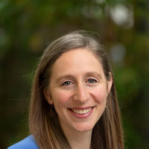

1. Do you have a personal connection or professional experience with someone who has an intellectual/developmental disability (IDD)?
If yes, would you describe its impact on you and your candidacy?
If not, what have you learned about people with intellectual or developmental disabilities and how has it impacted your candidacy?
I have both personal and professional experiences with people who have an IDD. In my extended family, several of my loved ones have been on the journey finding the right support for their kids who are on the autism spectrum. This has given me the understanding of the challenges faced by many families navigating in the public education system with kids who may have unique needs due to an IDD. As a City Councilmember, I have also connected with constituents over my nearly seven years on the council, who have shared challenges with the way we deliver city services and highlighted ways to make them more inclusive to people with an IDD. My biggest takeaway is that our system relies heavily on families to provide care for their loved ones, often footing large bills to get the support they need because our public schools and services are not always designed to accommodate without additional support. As a state legislator, one of my priorities is to support robust public education for every student no matter their income or if they have an IDD – and that will require dedicating greater funding to addressing students’ unique needs and the educators that support them.
2. What policies and systems are you aware of that impact the lives of people with IDD and their families? If elected, what responsibility would you have to change those policies or systems?
Many people with IDD depend on Medicaid for health care and long-term services, on Supplemental Security Income for basic income, and on the Developmental Disabilities Administration for the home and community supports that make independent living possible. As a state representative, I would have a direct responsibility over the budget and policy choices that determine whether these systems work. That means protecting and growing Medicaid and DDA funding, addressing provider wages and workforce shortages so services actually exist, and defending these programs against federal rollbacks that threaten the people who can least absorb the loss.
3. If elected, what are your top three priorities, and how would people with IDD and their families benefit from each priority?
Education and Affordability: As a mom of two young kids, I will fight to stop cuts to early learning, childcare and to build an education funding model that adequately supports unique student needs, including special education and early intervention, without overburdening teachers or districts.
Climate Action: I believe we have a moral imperative to act on climate change for current and future generations. Having to greenspace is critical for mental health and wellness for everyone, including people with IDD, and it’s what makes our quality of life so special in Washington. Making sure that these spaces are accessible and outdoor education programming is inclusive to people with IDD is something I will support as a legislator.
Responding to federal attacks: I will take every action necessary to protect residents from federal threats to health care and our civil liberties. For families who rely on Medicaid and SSI, defending these lifelines from federal cuts is paramount.
4. When you have questions about how to best support people with IDD and their families, what or who are your trusted resources?
I believe in listening to the people closest to the issue first including self-advocates and families who live in these systems every day. I would rely on The Arc of Washington and the Community Advocacy Coalition, the Developmental Disabilities Council, and service providers and direct-support professionals on the ground. From my regional work I also draw on partners like Hopelink, where I serve on the board, and the human-services organizations in our community. My approach has always been to bring the voices of those most impacted by a policy to the table early to ensure that it can best serve their needs.
5. The national trend -- and legal mandate --- supports transitioning individuals with IDD out of institutional settings and into community-based care, which is not only the best practice but also the most cost-effective approach. Studies consistently show that community-based services cost significantly less per person than institutional care while providing greater independence and quality of life. In Washington the cost of care in a Residential Habilitation Center (RHC) is more than double the cost of equivalent services in community settings.
Although Washington has made progress, continued efforts are needed to align with best practices, civil rights, federal priorities, and fiscal responsibility. Transitioning more individuals into community-based care will allow the state to reinvest savings into services for much needed community-based services.
How do you believe Washington state should approach investment in home and community based services for people with IDD in the next five years?
Washington should keep shifting investment toward home- and community-based services, which cost far less than institutional care while delivering greater independence and quality of life. The savings could be reinvested directly into the community-based services families are still waiting for. Doing this well over five years means tackling the waitlist, paying direct-support professionals a living wage so the workforce exists to deliver care, and expanding accessible housing and employment support.
6. Is there any other information you'd like constituents with intellectual or developmental disabilities and their family and friends to know?
I want families to know that I see them and that I will be an accessible, accountable representative who follows through. Throughout my time on the Redmond City Council I have shown up, listened, and turned community conversations into concrete policy. I will bring that same persistence to Olympia on behalf of people with IDD and their families, and I would be honored to earn the support of The Arc of Washington and to be a genuine partner in this work.

