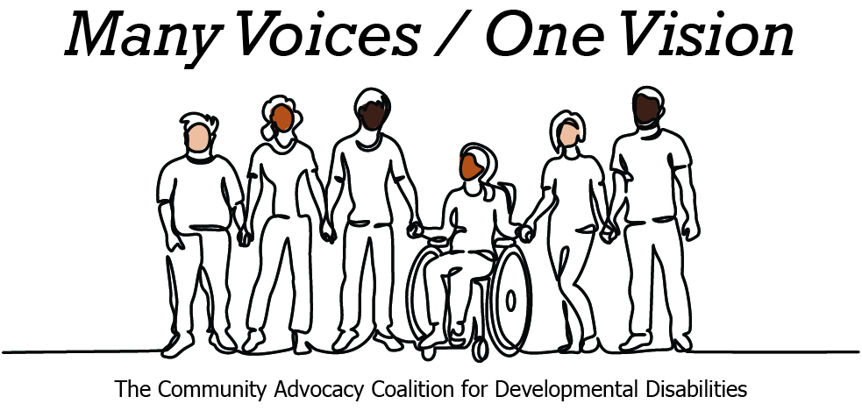 | 

2026 Legislative Candidate Survey
Questions for Legislative Candidates — The Arc of Washington
The Community Advocacy Coalition for Developmental Disabilities
The Children’s Campaign Fund

Name: Maria Littlesun  Position: House  Legislative District: 35  Email: info@electmarialittlesun.com  Website: electmarialittlesun.com | 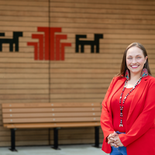

1. Do you have a personal connection or professional experience with someone who has an intellectual/developmental disability (IDD)?
If yes, would you describe its impact on you and your candidacy?
If not, what have you learned about people with intellectual or developmental disabilities and how has it impacted your candidacy?
As a mother to a nonverbal child with autism, my life is centered around making sure he gets the care he needs in and outside of our home. My priorities reflect my experience and dedication to issues faced by children living with disabilities – strong and funded public schools, accessible health care, economic stability for families of all kinds, and wraparound service housing in our community, so people can affordably and sustainably live in our community as they age.
2. What policies and systems are you aware of that impact the lives of people with IDD and their families? If elected, what responsibility would you have to change those policies or systems?
I am very aware of the failings in our school systems, and how lacking state funding has worsened outcomes for nontraditional students. I have to show up for my son as an advocate and am very involved in Shelton Public Schools to help ensure all students have the tools they need to succeed. I would enhance state funding for public schools, bolster dual language programs, and improve special education resourcing so every student receives the care they need so they can learn, and parents can trust their schools.
3. If elected, what are your top three priorities, and how would people with IDD and their families benefit from each priority?
My priorities are public education, community affordability, and accessible health care. Families and people with IDD would benefit from reforms to health care systems that make care affordable, and easy to reach, full-service housing and low-income housing supply, as well as improved public education funding and programming.
4. When you have questions about how to best support people with IDD and their families, what or who are your trusted resources?
My trusted resources are paraeducators in my school district, who I work extremely closely with as a mother with an autistic child in Shelton Schools. As a social worker and CNA, I have many connections in health care and public service spaces that are very aware of ongoing issues with IDD support systems in the 35th LD and the greater state of Washington.
5. The national trend -- and legal mandate --- supports transitioning individuals with IDD out of institutional settings and into community-based care, which is not only the best practice but also the most cost-effective approach. Studies consistently show that community-based services cost significantly less per person than institutional care while providing greater independence and quality of life. In Washington the cost of care in a Residential Habilitation Center (RHC) is more than double the cost of equivalent services in community settings.
Although Washington has made progress, continued efforts are needed to align with best practices, civil rights, federal priorities, and fiscal responsibility. Transitioning more individuals into community-based care will allow the state to reinvest savings into services for much needed community-based services.
How do you believe Washington state should approach investment in home and community based services for people with IDD in the next five years?
I fully support building housing in communities that are often underserved by health care and government service providers, in addition to urban areas. As a legislator I will build a coalition to expand affordable housing development and supportive housing that allows people to live independently and with dignity, regardless of their IDD and health status.
6. Is there any other information you'd like constituents with intellectual or developmental disabilities and their family and friends to know?
I work in elder care as a social worker, but have also worked closely with young people living with disabilities through in-home care. I support expanding support and funding from the state for in-home care so all communities can access the health care they need in preventative ways, rather than waiting until it’s too late.

