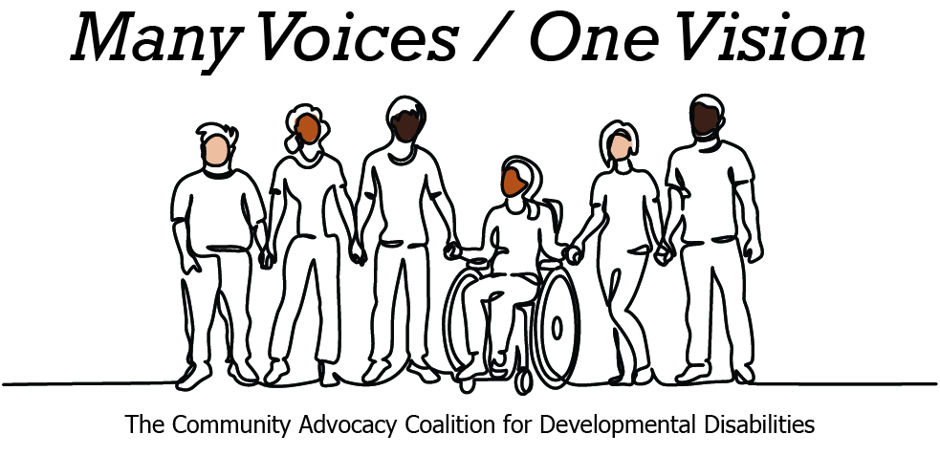 | 

2026 Legislative Candidate Survey
Questions for Legislative Candidates — The Arc of Washington
The Community Advocacy Coalition for Developmental Disabilities
The Children’s Campaign Fund

Name: Kevin Moynihan  Position: House  Legislative District: 19  Email: KevinFor19ld@gmail.com  Website: www.KevinMoynihan.com | 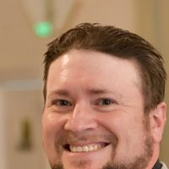

1. Do you have a personal connection or professional experience with someone who has an intellectual/developmental disability (IDD)?
If yes, would you describe its impact on you and your candidacy?
If not, what have you learned about people with intellectual or developmental disabilities and how has it impacted your candidacy?
Yes, my connection to this community is deeply personal. My oldest son is on the autism spectrum, and both my youngest son and I have ADHD. Living this reality every single day has shaped my worldview, my parenting, and my candidacy. I know firsthand the sheer exhausting effort it takes to advocate for your children in a system that often feels like it's designed to make you give up. I have navigated the endless red tape of securing Individualized Education Programs (IEPs), fought for classroom accommodations, and felt the anxiety of wondering what support systems will exist for my children as they transition into adulthood. My candidacy is fueled by the lived experience of a parent who knows that our current safety nets are frayed, and I am running to ensure that families like mine are never left to fight these battles completely alone.
2. What policies and systems are you aware of that impact the lives of people with IDD and their families? If elected, what responsibility would you have to change those policies or systems?
I am acutely aware of the systems that dictate our families' daily lives: the complex rules of Medicaid and SSI, the massive administrative backlogs at the Developmental Disabilities Administration (DDA), and the incredibly stressful, adversarial process that public school IEP meetings can often become for parents. If elected, I believe my primary responsibility is to humanize these systems. I will fight to slash the bureaucratic red tape that delays access to critical therapies and respite care, and champion legislation that properly funds and supports special education departments in our schools. As a representative, I will use my platform to ensure the state stops treating these essential human services as optional line items to be negotiated away.
3. If elected, what are your top three priorities, and how would people with IDD and their families benefit from each priority?
Restructuring K-12 Education Funding: I will fight to fully fund public education so rural districts don't have to rely on regressive local property levies. Benefit: This guarantees our rural schools have the baseline, predictable funding needed to hire and retain dedicated special education teachers, paraeducators, and specialists, ensuring students with IDD receive the robust, legally mandated support they deserve.
Dismantling Rural Healthcare Deserts: I am fighting to expand rural healthcare infrastructure and establish a single-payer healthcare system. Benefit: Neurodivergent individuals and people with IDD in rural areas will be able to access specialized medical care, developmental pediatricians, occupational therapy, and mental health services locally, rather than being forced to travel hours outside of our legislative district.
Investing in Heavy-Civil Infrastructure: Directing state capital into local infrastructure creates family-wage union jobs and stabilizes our regional economy. Benefit: A healthy local economy generates a strong local tax base, which is necessary to fund accessible, reliable public transit, ADA-compliant parks, and local community programs that prevent isolation and keep individuals with IDD fully integrated.
4. When you have questions about how to best support people with IDD and their families, what or who are your trusted resources?
My primary trusted resources are my fellow parents, self-advocates, and the frontline educators and healthcare workers who live and work in these spaces daily. Organizationally, I rely on the lived expertise of self-advocate networks, the Washington State Developmental Disabilities Council, and local chapters of The Arc of Washington State. I look to these groups because they represent the authentic voices of people with IDD and their families, rather than the corporate healthcare consultants or state bureaucrats who only look at the system through a spreadsheet.
5. The national trend -- and legal mandate --- supports transitioning individuals with IDD out of institutional settings and into community-based care, which is not only the best practice but also the most cost-effective approach. Studies consistently show that community-based services cost significantly less per person than institutional care while providing greater independence and quality of life. In Washington the cost of care in a Residential Habilitation Center (RHC) is more than double the cost of equivalent services in community settings.
Although Washington has made progress, continued efforts are needed to align with best practices, civil rights, federal priorities, and fiscal responsibility. Transitioning more individuals into community-based care will allow the state to reinvest savings into services for much needed community-based services.
How do you believe Washington state should approach investment in home and community based services for people with IDD in the next five years?
Washington must aggressively prioritize and fund the transition toward home and community-based services (HCBS) over the next five years. To do this successfully, we have to treat the care economy with the respect it deserves. We cannot have robust community-based care if the direct support professionals (DSPs) and in-home caregivers are paid poverty wages. The state must invest heavily in raising wages and expanding benefits for care workers. By building a well-supported, stable care workforce, we ensure that individuals with IDD can live with dignity, autonomy, and safety in their own neighborhoods, while relieving the immense, unpaid physical and emotional burden currently placed on family caregivers.
6. Is there any other information you'd like constituents with intellectual or developmental disabilities and their family and friends to know?
I want our community to know that I am running a 100% corporate PAC-free campaign. I don't answer to the corporate insurance giants or private developers who view public support systems as financial targets. I am a working-class parent who knows exactly how high the stakes are for our kids. In Olympia, you won’t just have an ally in me, you will have a peer. I will bring our families’ lived experiences directly to the house floor to fight for the funding, safety, and community dignity that all of our children deserve

