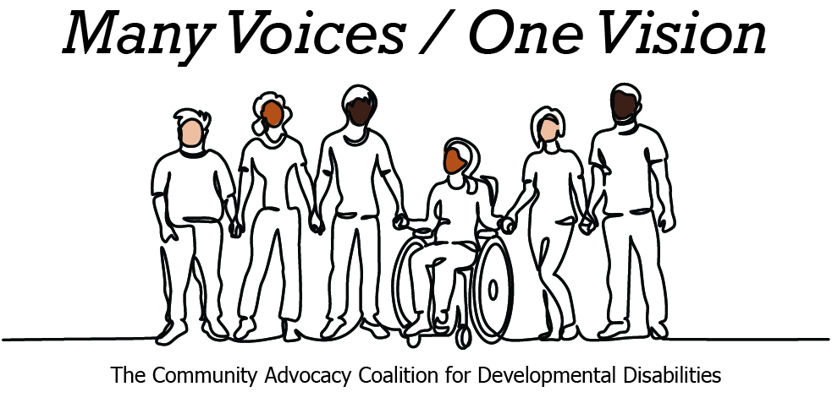 | 

2026 Legislative Candidate Survey
Questions for Legislative Candidates — The Arc of Washington
The Community Advocacy Coalition for Developmental Disabilities
The Children’s Campaign Fund

Name: Joe Timmons  Position: House  Legislative District: 42nd LD  Email: hello@votejoetimmons.com  Website: https://www.votejoetimmons.com/ | 

1. Do you have a personal connection or professional experience with someone who has an intellectual/developmental disability (IDD)?
If yes, would you describe its impact on you and your candidacy?
If not, what have you learned about people with intellectual or developmental disabilities and how has it impacted your candidacy?
While I do not have a close personal connection to someone with an intellectual or developmental disability, my work in public service has given me the opportunity to meet with self-advocates, families, educators, and service providers who have shared their experiences with me. Those conversations have reinforced how important it is to build systems that promote independence, inclusion, and opportunity rather than creating unnecessary barriers.
As a legislator, I believe it is my responsibility to listen to the people most directly impacted by the policies we create. Hearing from individuals with IDD and their families has strengthened my commitment to protecting community-based services, expanding access to housing, education, healthcare, and employment opportunities, and ensuring every Washingtonian has the support they need to live with dignity and participate fully in their community.
2. What policies and systems are you aware of that impact the lives of people with IDD and their families? If elected, what responsibility would you have to change those policies or systems?
People with intellectual and developmental disabilities and their families are impacted by many of the systems we oversee in the Legislature, including Medicaid, Developmental Disabilities Administration services, special education, employment supports, housing, and transportation. These systems should work together to help people live independently and participate in their communities while being able to access the services they need throughout their life.
I believe these programs should never be viewed as just line items in a budget. They have a real impact on the lives of individuals and families across our state, and for many, they provide essential support that makes independence and community inclusion possible. I will continue working to ensure our laws and budgets reflect that responsibility.
3. If elected, what are your top three priorities, and how would people with IDD and their families benefit from each priority?
My top priority is addressing affordability so Washingtonians and Washington families can continue to live and thrive in Whatcom County and throughout the state. That includes expanding affordable and accessible housing in places where people can easily reach work, medical appointments, and the services they rely on. It also means protecting community-based programs and recognizing that they are essential investments in people's independence, not simply budget items to be cut.
I also want to continue strengthening our education system so that every student receives a quality education and has the opportunity to succeed, including fully funding special education. Students with disabilities deserve the support they need to learn and prepare for whatever path they choose after graduation.
Another priority is making sure people can access quality healthcare close to home. That includes continuing to invest in behavioral health services and supporting families and caregivers who play such an important role in helping individuals with IDD live independently in their communities.
4. When you have questions about how to best support people with IDD and their families, what or who are your trusted resources?
The best resource is always the people most directly impacted. When I have questions, I start by listening to self-advocates, family members, caregivers, and the organizations that work with them every day. Their lived experiences are invaluable and help ensure the policies we pass reflect the real challenges people face.
I also value the expertise of advocacy organizations such as The Arc of Washington and the Community Advocacy Coalition for Developmental Disabilities, as well as educators, healthcare providers, and other community partners. Good public policy is built by listening, asking questions, and working together to find solutions.
5. The national trend -- and legal mandate --- supports transitioning individuals with IDD out of institutional settings and into community-based care, which is not only the best practice but also the most cost-effective approach. Studies consistently show that community-based services cost significantly less per person than institutional care while providing greater independence and quality of life. In Washington the cost of care in a Residential Habilitation Center (RHC) is more than double the cost of equivalent services in community settings.
Although Washington has made progress, continued efforts are needed to align with best practices, civil rights, federal priorities, and fiscal responsibility. Transitioning more individuals into community-based care will allow the state to reinvest savings into services for much needed community-based services.
How do you believe Washington state should approach investment in home and community based services for people with IDD in the next five years?
I believe Washington should continue investing in home and community-based services so people with intellectual and developmental disabilities can live where they choose and remain connected to their families and communities. That means making sure services are adequately funded while reducing wait times and ensuring individuals can access the supports they need close to home.
6. Is there any other information you'd like constituents with intellectual or developmental disabilities and their family and friends to know?
Thank you to everyone who has shared their experiences and trusted me with your stories. Serving on the board of the Children's Campaign Fund reinforced my belief that every child and family deserves the opportunity to thrive, and that public policy should reflect the needs of the people it serves.
As your state representative I carry these values with me, and my door is always open for conversations and opportunities to learn more. I am committed to continue listening to self-advocates, families, caregivers, and organizations like The Arc because I believe the best policies are shaped by the people they impact. I look forward to continuing to work together to ensure every Washingtonian has the opportunity to live with dignity and participate fully in their community.

