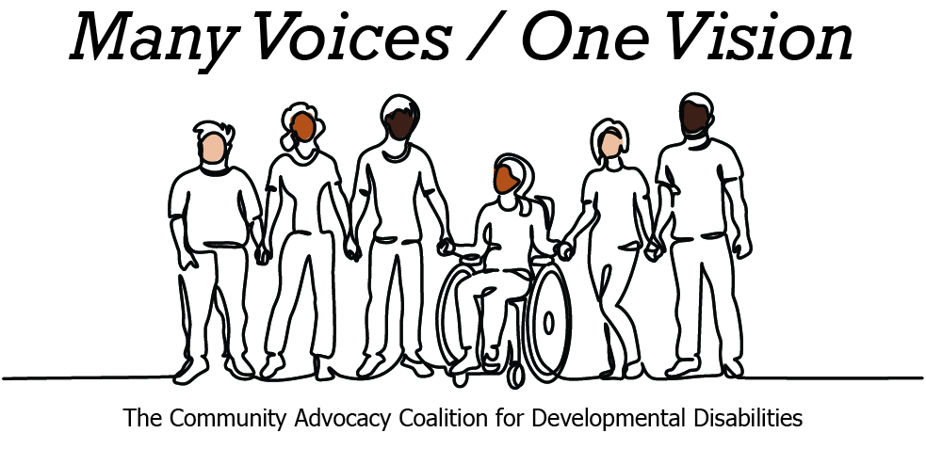 | 

2026 Legislative Candidate Survey
Questions for Legislative Candidates — The Arc of Washington
The Community Advocacy Coalition for Developmental Disabilities
The Children’s Campaign Fund

Name: Janice Zahn  Position: House  Legislative District: 41st  Email: info@janicezahn.org  Website: janicezahn.org | 

1. Do you have a personal connection or professional experience with someone who has an intellectual/developmental disability (IDD)?
If yes, would you describe its impact on you and your candidacy?
If not, what have you learned about people with intellectual or developmental disabilities and how has it impacted your candidacy?
Yes, I have a nephew and my cousin’s son who are on the autism spectrum. I also have many co-workers from the Port of Seattle who have family with IDD and some who are IDD themselves. I have seen and value the contribution from the supported employee who has worked for the Port of Seattle for many years. Ensuring that everyone can feel like they belong as their authentic self matters. People’s worth cannot be defined by their intellectual abilities and we as a society must value and support everyone. I have seen firsthand the challenges with my nephew and cousin’s son, navigating our education system as neurodiverse learners, as well as the deep and traumatic impact to their parents and family. We must do better at supporting both the individual who is IDD as well as their family. We are seeing more impacts in our education system as well as our workplaces, when resources and funding is reduced. Our IDD people are the first to be impacted. I have also seen in our criminal justice system, that they are not equiped and trained in their interactions with our IDD community. This is detrimental.
2. What policies and systems are you aware of that impact the lives of people with IDD and their families? If elected, what responsibility would you have to change those policies or systems?
People with IDD and their families are affected by Medicaid Home and Community-Based Services, employment supports, special education, accessible housing, transportation, behavioral health, respite care, and the Direct Support Professional workforce. Long waitlists, workforce shortages, and gaps during the transition from school to adulthood continue to create barriers.
The Legislature has taken important steps, including funding supported employment and community inclusion services in the 2025-27 budget and passing legislation to improve the utilization of Developmental Disabilities Administration waivers.
As a legislator, I believe we must continue building on this progress by strengthening the direct care workforce, expanding community-based services, and ensuring individuals with IDD and their families have a voice in policymaking.
3. If elected, what are your top three priorities, and how would people with IDD and their families benefit from each priority?
Affordable Housing: I will continue supporting investments in affordable, accessible housing so individuals with IDD have greater opportunities to live independently in their communities.
Strong Public Services: I support investing in behavioral health, long-term care, respite services, and community-based supports while strengthening the Direct Support Professional workforce. Protecting these services is especially important during difficult budget decisions.
Economic Opportunity: Everyone deserves the opportunity to succeed. I support expanding supported employment, workforce development, apprenticeship opportunities where appropriate, and inclusive employment so people with disabilities can achieve greater independence and financial security.
4. When you have questions about how to best support people with IDD and their families, what or who are your trusted resources?
The most important resources are people with lived experience. I will continue listening to self-advocates, families, caregivers, disability rights organizations, service providers, educators, county developmental disability programs, and organizations such as The Arc of Washington and the Washington State Developmental Disabilities Council. Good public policy begins by listening to those most directly affected and using evidence to guide decisions.
5. The national trend -- and legal mandate --- supports transitioning individuals with IDD out of institutional settings and into community-based care, which is not only the best practice but also the most cost-effective approach. Studies consistently show that community-based services cost significantly less per person than institutional care while providing greater independence and quality of life. In Washington the cost of care in a Residential Habilitation Center (RHC) is more than double the cost of equivalent services in community settings.
Although Washington has made progress, continued efforts are needed to align with best practices, civil rights, federal priorities, and fiscal responsibility. Transitioning more individuals into community-based care will allow the state to reinvest savings into services for much needed community-based services.
How do you believe Washington state should approach investment in home and community based services for people with IDD in the next five years?
Washington should continue expanding high-quality home and community-based services that maximize independence, choice, and inclusion. We should reduce waitlists, strengthen the Direct Support Professional workforce through competitive wages and career pathways, expand respite care, improve transition services for young adults, and increase access to supported employment and accessible housing.
I also support continuing the work reflected in recent legislation to improve waiver utilization and strengthen community inclusion, while exploring additional improvements such as expanding respite care and improving employment transition services.
Community-based services are consistent with best practices, civil rights, and person-centered care. While recognizing that some individuals have complex needs requiring specialized settings, we should ensure every person has meaningful choices and access to the least restrictive environment that best meets their needs.
Lastly, I believe we have to cut redundancies like that in my HB 2230, designed to streamline monitoring and oversight activities related to community residential service business providers in Washington State. The bill aims to improve efficiency in regulatory oversight, ensuring that these providers meet standards while reducing administrative burdens. Investment in people care and not bureaucracy.
6. Is there any other information you'd like constituents with intellectual or developmental disabilities and their family and friends to know?
Every Washingtonian deserves the opportunity to live with dignity, independence, and respect. I am committed to listening to people with IDD and their families and ensuring their experiences help shape public policy. I am proud to be endorsed by the Children’s Campaign Fund for my re-election campaign this year. I look forward to continued partnership, learning and advancing state policies that improve the lives of our IDD community. We all thrive when we all can thrive.

