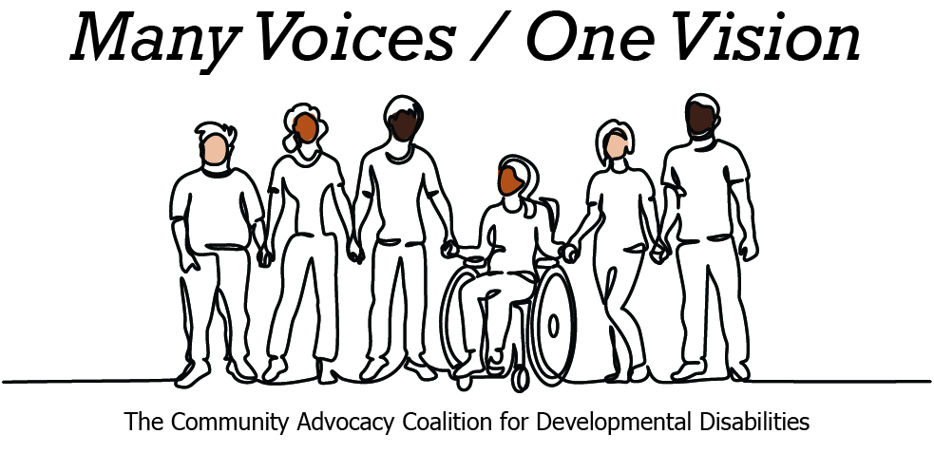 | 

2026 Legislative Candidate Survey
Questions for Legislative Candidates — The Arc of Washington
The Community Advocacy Coalition for Developmental Disabilities
The Children’s Campaign Fund

Name: Derek Sarley  Position: House  Legislative District: 16  Email: sarleyforwashington@gmail.com  Website: sarleyforwashington.com | 

1. Do you have a personal connection or professional experience with someone who has an intellectual/developmental disability (IDD)?
If yes, would you describe its impact on you and your candidacy?
If not, what have you learned about people with intellectual or developmental disabilities and how has it impacted your candidacy?
Two experiences have best informed my understanding of the issues this community faces, though I have much more to learn.
The first is my ten years on the school board in Walla Walla. We have dramatically changed our practices for serving our students with special needs during that time, with a focus on inclusion and family engagement. Our district has found grants to fund training in new professional practices, like Universal Design for Learning, to better equip staff working in inclusive classrooms. A year in advance of our last strategic plan refresh, I pushed for the development of a new parent advisory committee, to identify gaps and opportunities for our next phase of improvement. And last year, we negotiated a new approach to IEP meetings that has significantly increased teacher participation in these important discussions.
Professionally, I also worked for many years with an organization that helped individuals receive their promised Social Security Disability Benefits, and then helped them return to work as they were able to medically recover. We advocated for fixing that broken system as part of a broad coalition that saw Congress appropriate new funding specifically to catch back up.
In my current campaign, I have been learning much more about the opportunities for improvement in Washington’s support for individuals with disabilities and their families.
2. What policies and systems are you aware of that impact the lives of people with IDD and their families? If elected, what responsibility would you have to change those policies or systems?
One concrete example I have been hearing much about is the lack of flexibility in the supports that Washington provides for individuals with disabilities and their parent caregivers. Any system of public payments needs an accountability mechanism, but an individual’s care team knows that person best and is best suited to make judgments about the kinds of activities and supports they need.
I also know that even these rigid programs are at risk, with funding cuts that will see families applying today finding themselves on waitlists next year once they qualify. The state’s financial issues are real, but we can’t balance our budget on the backs of the people most in need of support.
3. If elected, what are your top three priorities, and how would people with IDD and their families benefit from each priority?
Affordability and economic opportunity is first. This touches the lives of every working family in our state. When the cost of everything increases -- from housing to healthcare to gas and groceries -- this stretches family budgets to the breaking point. It is especially challenging for families where one parent may have to stay home to provide constant care.
My second is education. We need strong, well-funded schools. Parents of children with special needs know just how hard they have to fight to get their children the supports they need to be successful in school. In many cases, that goes back to funding, though it also has to do with professional practice.
And then, in the short term, we have to balance the state’s budget. That means prioritizing the services we must provide and funding them, rather than just trying to maintain absolutely everything and inevitably having to make continuous cuts that are deeply at odds with our values.
4. When you have questions about how to best support people with IDD and their families, what or who are your trusted resources?
In my work on the school board, I have a few community sounding boards I can go to when I need more information about the issues affecting students with disabilities. I am also building new relationships through this campaign that are helping me to better understand what the world looks like beyond age 18 or 22. I will accept any invitation to places where I can learn more about the issues facing this community.
5. The national trend -- and legal mandate --- supports transitioning individuals with IDD out of institutional settings and into community-based care, which is not only the best practice but also the most cost-effective approach. Studies consistently show that community-based services cost significantly less per person than institutional care while providing greater independence and quality of life. In Washington the cost of care in a Residential Habilitation Center (RHC) is more than double the cost of equivalent services in community settings.
Although Washington has made progress, continued efforts are needed to align with best practices, civil rights, federal priorities, and fiscal responsibility. Transitioning more individuals into community-based care will allow the state to reinvest savings into services for much needed community-based services.
How do you believe Washington state should approach investment in home and community based services for people with IDD in the next five years?
I would not want to misrepresent a depth of understanding on this question that I don’t yet have. I can talk about a few general principles, given my experience with how change often happens in state government.
The first is that building a more robust system of community care has to happen before cutting support for institutional care. The incentives cut the other way. Make the cuts first, then “figure it out” later. We cannot make things worse on our way to making things better.
The second is that workforce development will be a huge part of this. We want well-qualified and appropriately-compensated people in these roles, without adding a bunch of new hurdles that dissuade people from pursuing these careers.
Finally, every decision has to be made on the basis of what’s best for the individual. We have done a lot of work the last few years to increase the period of time each day that our students with special needs are spending in the least restrictive environment. But our special education director has been clear that 100% is not our goal. Every student is unique. Some will have needs that can be better met in periods of time spent in different classroom settings. Her team always works to make those decisions based on the student, not statistics.
6. Is there any other information you'd like constituents with intellectual or developmental disabilities and their family and friends to know?
That I am here to listen to you and that the reality is that doing all of this work well will cost money. It’s easy for politicians to say they oppose program cuts in tough budget years. It can be much harder to stand up to local voters to make the case for why Washington’s upside-down tax code is part of that problem and needs to continue to change.
We can make program changes to streamline qualification and improve flexibility to ensure the people closest to the individual with disabilities are making decisions. But resourcing matters too.

