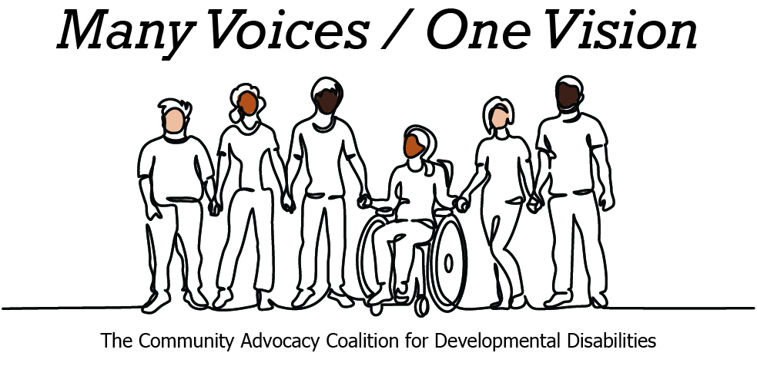 | 

2026 Legislative Candidate Survey
Questions for Legislative Candidates — The Arc of Washington
The Community Advocacy Coalition for Developmental Disabilities
The Children’s Campaign Fund

Name: David Berg  Position: House  Legislative District: 25  Email: david@electdavidberg.com  Website: www.ElectDavidBerg.com | 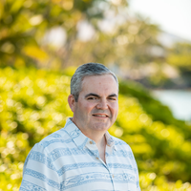

1. Do you have a personal connection or professional experience with someone who has an intellectual/developmental disability (IDD)?
If yes, would you describe its impact on you and your candidacy?
If not, what have you learned about people with intellectual or developmental disabilities and how has it impacted your candidacy?
I have personal connections with a teen with autism and with an adult who has suffered a traumatic brain injury and resulting intellectual disability. I have professional connections through my work as a school board director to students and young adults with a range of intellectual or developmental disabilities.
Navigating both the educational system and the healthcare system is often unnecessarily complicated, and sometimes seems designed more about adding obstacles than providing access. While I understand the need for documentation to ensure the right services are delivered and that they're having the desired results, we have to make sure that people still come first. Families and guardians often need assistance of their own to make sure that the people they care for get what they need. We need systems designed to look for ways to provide supports, and not systems designed to look for ways to deny supports.
2. What policies and systems are you aware of that impact the lives of people with IDD and their families? If elected, what responsibility would you have to change those policies or systems?
As a school board director, I've worked closest to the P-22 education system and the school to adult transition. Our Puyallup Advance Program focuses on job preparation and independent adult living skills to help students succeed after high school. It's important that we continue to work to close any gaps between the programs under oversight of OSPI and those under oversight of DSHS so that young adults continue to get the supports they need. I'll continue to work to build and support systems built around creating a culture of access, and not one defined by gatekeeping.
3. If elected, what are your top three priorities, and how would people with IDD and their families benefit from each priority?
Public education is at the core of my campaign and that absolutely includes supporting the programs in our schools that address the education to adulthood transition. I've also been a champion for increasing our community based support infrastructure. Our healthcare and support professionals are facing workloads that exceed their ability to deliver needed services. Adding capacity in those areas, and ensuring the people doing the work are well represented and well paid benefits the entire community. We can't continue to rely on a system that seeks short-term savings, which increasing long-terms costs. That means investing early in building systems that work, so that we don't have to spend more on remediation later.
4. When you have questions about how to best support people with IDD and their families, what or who are your trusted resources?
It's commonly said that someone has an open door policy. That's not enough. I work to invite people closest to the issues to come through that door and be a part of the discussion. That can be individuals, family members, school districts, teachers, and the advocacy work of the Arc of Washington. Legislators need to know what they know, and know where they need more information. The best decisions are made when we work together to find solutions.
5. The national trend -- and legal mandate --- supports transitioning individuals with IDD out of institutional settings and into community-based care, which is not only the best practice but also the most cost-effective approach. Studies consistently show that community-based services cost significantly less per person than institutional care while providing greater independence and quality of life. In Washington the cost of care in a Residential Habilitation Center (RHC) is more than double the cost of equivalent services in community settings.
Although Washington has made progress, continued efforts are needed to align with best practices, civil rights, federal priorities, and fiscal responsibility. Transitioning more individuals into community-based care will allow the state to reinvest savings into services for much needed community-based services.
How do you believe Washington state should approach investment in home and community based services for people with IDD in the next five years?
Our healthcare infrastructure is stretched, sometimes beyond the breaking point. We need to continue to invest in developing and retaining direct support professionals and family caregivers as part of addressing our healthcare system.
Proactively funding transition programs creates better results that trying to go back and fix problems later. We have to continue to invest in the systems that are preparing our students who are leaving the P-22 educational system so that they can develop skills that will best serve them and their long-term independence.
6. Is there any other information you'd like constituents with intellectual or developmental disabilities and their family and friends to know?
Everyone belongs. Everyone is valued. I'll work to support systems that find ways to provide services, and to end systems that are built to add obstacles.

