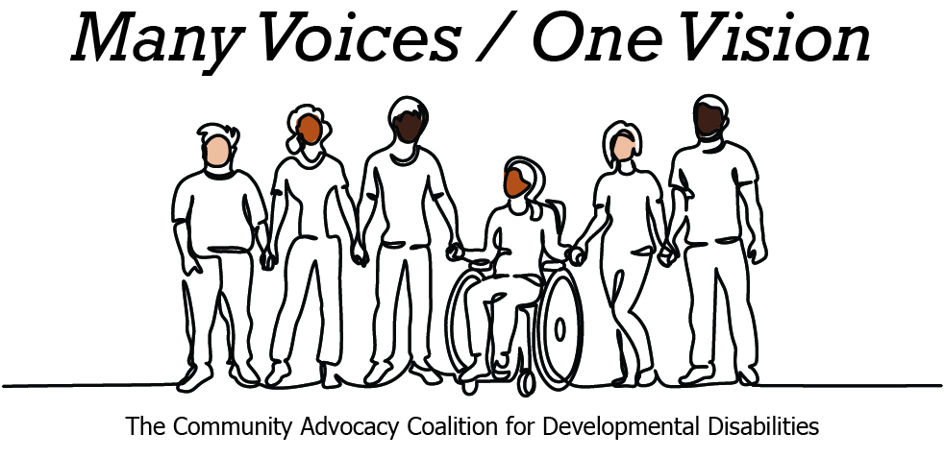 | 

2026 Legislative Candidate Survey
Questions for Legislative Candidates — The Arc of Washington
The Community Advocacy Coalition for Developmental Disabilities
The Children’s Campaign Fund

Name: Chipalo Street  Position: Senate  Legislative District: 37  Email: info@electchipalo.com  Website: www.electchipalo.com | 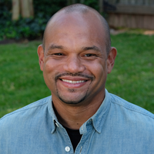

1. Do you have a personal connection or professional experience with someone who has an intellectual/developmental disability (IDD)?
If yes, would you describe its impact on you and your candidacy?
If not, what have you learned about people with intellectual or developmental disabilities and how has it impacted your candidacy?
Yes, I have one cousin with Down syndrome and another with Cerebral Palsy. It has reinforced for me that disability policy is not abstract. It affects whether people can live independently, find meaningful work, use transportation, and be treated with respect. It also affects families and caregivers, who too often have to fight systems that should be helping them.
As a legislator, that personal connection makes me especially committed to fully funding special education, protecting Apple Health and long-term services and supports, investing in accessible housing and transportation, and centering people with disabilities in the policies that affect their lives.
2. What policies and systems are you aware of that impact the lives of people with IDD and their families? If elected, what responsibility would you have to change those policies or systems?
Almost all policies impact people with IDD. That’s why it was so important to pass Nothing About Us Without Us. That gives folks with IDD a say in the policies that impact their daily lives.
Then there are specific policies targeted at the IDD community. For example, I’m working with the taxi cab industry and Arc of King County to increase availability of wheel chair accessible vehicles.
3. If elected, what are your top three priorities, and how would people with IDD and their families benefit from each priority?
Fixing our regressive tax code
Fixing Washington’s upside-down tax code is one of the most important things we can do to make our state more affordable and more just. For too long, working families have paid a higher share of their income in taxes than the wealthiest households, while too many profitable corporations have benefited from outdated preferences and loopholes. That limits our ability to fund the things families rely on — child care, schools, housing, behavioral health, transportation, and basic public services — without leaning even harder on regressive taxes.
We have made real progress during my time as Vice Chair of the Finance committee. The new Millionaires Tax is a huge win for progressive revenue. I also ran bills to strengthen the estate tax so extreme inherited wealth contributes to the public good. Despite these wins, there’s still a long way to go and this remains a key focus of mine so that we can adequately fund the services Washingtonians, including those with IDD, depend on.
Delivering affordable housing and tenant protections
Our neighbors are often pushed out due to the rising cost of living in our community, elders are forced to sell their homes due to increasing property taxes, and renters have few protections. I have firsthand experiences with the problems in the housing market and power imbalance between owners and renters. In Olympia, I will ensure tenants have the proper protections, fix the forces which have created the current housing crisis, protect our current residents and homeowners, and strengthen our safety net so that temporary hardships do not end in people losing their homes. Housing instability has particularly harsh impacts on individuals and families with IDD.
Supporting childcare, education, and pathways for our kids
The costs to care for and educate our children continue to climb for families in Washington and force them to make sacrifices. My parents felt those sacrifices as they camped out overnight to get me into the best public schools. When we ensure all our schools and students have the resources they need, we will see incredible results.
4. When you have questions about how to best support people with IDD and their families, what or who are your trusted resources?
In the legislature, I turn to Rep. Farivar and Rep. Taylor. Outside of the legislature, my cousin with cerebral palsy is a great person who can provide perspective.
5. The national trend -- and legal mandate --- supports transitioning individuals with IDD out of institutional settings and into community-based care, which is not only the best practice but also the most cost-effective approach. Studies consistently show that community-based services cost significantly less per person than institutional care while providing greater independence and quality of life. In Washington the cost of care in a Residential Habilitation Center (RHC) is more than double the cost of equivalent services in community settings.
Although Washington has made progress, continued efforts are needed to align with best practices, civil rights, federal priorities, and fiscal responsibility. Transitioning more individuals into community-based care will allow the state to reinvest savings into services for much needed community-based services.
How do you believe Washington state should approach investment in home and community based services for people with IDD in the next five years?
The transition from RHCs to community-based care must be planned carefully and humanely. I would start by moving the least acute residents first, while using that process to build provider capacity, workforce pipelines, housing options, and quality oversight. Then, as the community system becomes stronger, we can transition individuals with more complex needs with the appropriate supports already in place.
Savings from reducing reliance on institutional care should be reinvested directly into community services, not swept elsewhere. The goal should be a system that honors civil rights, improves quality of life, supports families and caregivers, and ensures every person has access to the right level of care in the least restrictive setting possible.
6. Is there any other information you'd like constituents with intellectual or developmental disabilities and their family and friends to know?
My proverbial office door is always open and I’m ready to partner on improving the lives of people with IDDs.

