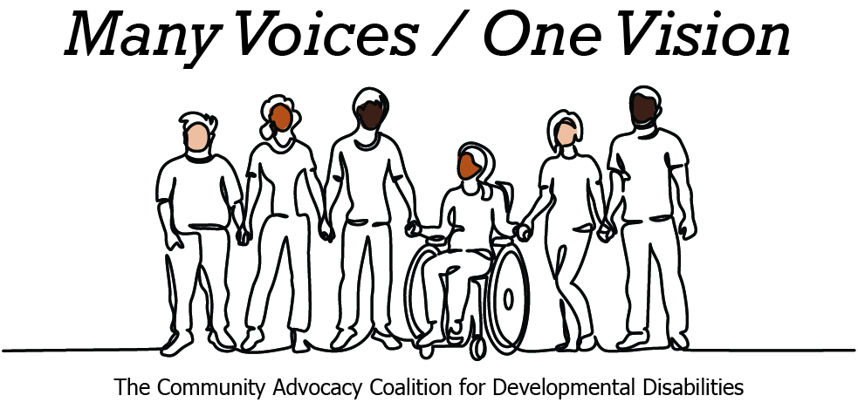

2026 Congressional Candidate Survey
Questions for Congressional Candidates — The Arc of Washington
The Community Advocacy Coalition for Developmental Disabilities

Name: Carmela Conroy  Position: House  Congressional District: WA-05  Email: carmela@conroy4congress.com  Website: conroy4congress.com | 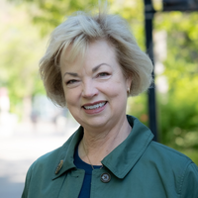

1. Do you have a personal connection or professional experience with someone who has an intellectual/developmental disability? (I/DD) If yes, would you describe its impact on you and your candidacy? If not, what have you learned about people with intellectual or developmental disabilities and how has it impacted your candidacy?
Yes. As a deputy prosecutor in Spokane County, I addressed cases involving people who could not speak for themselves: survivors of violence, people whose vulnerabilities made them targets. That work shaped how I think about public safety: it starts with the people who need the most support, not the least.
In the Foreign Service, I spent time in countries where disability meant invisibility. People with intellectual and developmental disabilities were hidden from public life, denied education, denied medical care. The contrast with what we have in the United States, through the ADA, Medicaid, and decades of family advocacy is real. But so are the gaps.
I am committed to restoring funding for public education, including support for children with special educational needs. That is not a throwaway line. Families throughout this district have shared with me the immense role that Special Education fulfills.
I have spent the past year visiting the Fifth's counties and meeting people in their communities. Parents of children with IDD have told me what the waitlists look like, what happens when a provider leaves a rural county, and what it costs to hold a family together when the system is not keeping its end of the deal. Those conversations have informed how I think about Medicaid, housing, and what a member of Congress owes the people in her district who need the most help.
2. What policies and systems are you aware of that impact the lives of people with IDD and their families? If elected, what responsibility would you have to change those policies or systems?
Medicaid is the backbone. Most people with IDD depend on Medicaid for health coverage and for the Home and Community Based Services that let them live at home instead of in an institutional or hospital setting. When Congress cuts Medicaid, people with intellectual and developmental disabilities are the first to feel those cuts.
The One Big Beautiful Bill Act put Medicaid on the chopping block. The per capita cap structure and the work reporting requirements in that bill threaten coverage for people with IDD who cannot work or whose work looks different from what a bureaucratic form might recognize. As a member of Congress, I would vote against any bill that cuts Medicaid and fight to restore the funding that has already been lost.
Supplemental Security Income is the other lifeline. SSI has not been updated since 1984. The asset limit of $2,000 for an individual and $3,000 for a married couple punishes people for saving and punishes them for getting married. I support legislation to raise those limits and eliminate the marriage penalty.
Beyond Medicaid and SSI, the Individuals with Disabilities Education Act funds early intervention and P-21 education services. IDEA has never been fully funded by Congress. The federal government promised 40 percent of the cost and has never delivered more than about 15 percent. That gap falls on local school districts and on families.
The Americans with Disabilities Act is the civil rights foundation. Housing, transportation, employment, community access: every one of those systems touches IDD families, and every one of them deserves a Representative that fights for funding and closes the gaps between expectation and reality.
As a U.S. Representative, my job would be to vote on the appropriations and authorizing legislation that fund these programs, to conduct oversight of the agencies that run them, and to make sure the people in Washington's 5th District who depend on these systems have someone in Congress who listens to their hopes, dreams, needs, and concerns.
3. If elected, what are your top three priorities, and how would people with IDD and their families benefit from each priority?
My three priorities are bringing down costs for working families, saving rural hospitals, and restoring America's standing in the world. Each one intimately affects the IDD community.
Bringing down costs. Families caring for a loved one with IDD face costs that most families do not--adaptive equipment, specialized care, transportation to providers who may be hours away. When grocery prices climb and wages stay flat, those families are hurt the most. I will fight to end the tariffs that raised prices across Eastern Washington and push for child care that costs less than rent, while making sure Medicaid and SSI keep pace with what families actually pay.
Saving rural hospitals. In this district, hospitals like Whitman in Colfax, Mount Carmel in Colville, East Adams in Ritzville, and Columbia County in Dayton are one bad Medicaid cut away from closing. When a rural hospital closes, people with IDD lose access to emergency care, behavioral health, and the providers who know them. I will fight to stabilize federal funding for rural hospitals, protect Medicaid, and build the healthcare-workforce pipeline in the communities that need it. Further, I am committed to extending Medicaid coverage to all children from birth to their 19th birthdays, which would close gaps that hit kids with IDD and their families.
Restoring America's standing in the world. The audacious and contemptible treatment of immigrants, BIPOC, and LGBTQIA+ individuals is reprehensible, and many of our trade partners agree. Because a stable economy depends upon trade and trade depends upon healthy relationships and good standing, America's international image directly influences the economic burdens faced by its citizens. Furthermore, a stable economy depends on trade. Eastern Washington wheat, apples, and cherries feed the world. When tariffs shut down export markets and shrinks demand for our crops, the economic pain reaches every family in this district, including the ones already stretching every dollar to care for a family member with a disability. Rebuilding smart trade policy is a path to predictability for IDD families.
4. When you have questions about how to best support people with IDD and their families, what or who are your trusted resources?
I start with the people who live it. Self-advocates and their families are the first experts. No policy conversation about IDD should happen without them at the table.
Organizations like The Arc of Washington State and the Community Advocacy Coalition for Developmental Disabilities have decades of expertise and a statewide view of what is working and what is failing. I would look to them as trusted advisors on federal legislation affecting the IDD community.
I would also consult with the Developmental Disabilities Administration at the state level, special education directors in our school districts, and direct support professionals who do the day-to-day work.
5. Home and Community Based Services (HCBS) are Medicaid services that are essential for individuals with IDD. They provide support for daily living (such as bathing, dressing, eating, and managing medication), having a job, accessing the community, and giving families a break from providing 24/7 care. Currently HCBS services are optional but nursing home services are an entitlement. The average US cost per year for a nursing home is $111,000, compared to $17,000 to provide in-home supports. Currently, HCBS services are under threat because of the HR1 cuts to Medicaid. Many states have years-long waiting lists for HCBS services. Do you support strengthening Home and Community Based Services (HCBS) and making them an entitlement? Why or why not?
Yes, I support making Home and Community Based Services an entitlement.
The math alone makes the case. HCBS is better for the person and better for the taxpayer. Waiting lists for HCBS services mean families are left providing 24/7 care with no break, or their loved one ends up in a more expensive, more restrictive institutional setting.
Medicaid is already under threat. The One Big Beautiful Bill Act imposed per capita caps and work reporting requirements that put HCBS funding at risk. I will vote to restore Medicaid funding to previous levels, fight any bill that treats HCBS as optional, and support federal legislation that strengthens community-based services. Our Constitution guarantees life, liberty, and the pursuit of happiness--not waitlists and exorbitant costs.
6. People with IDD frequently rely on The Supplemental Security Income (SSI) program as their basic source of income. SSI has not been updated since 1984. Currently, individuals on SSI will lose their benefits if they have assets of more than $2000 (Excluding their home and care) and married couples can only have $3000. This creates a disincentive for individuals with IDD to marry. Do you support raising the asset limit, and eliminating the "marriage penalty" for recipients of SSI? Why or why not?
Yes, I support raising the asset limit and eliminating the marriage penalty.
The $2,000 asset limit means a person with IDD who saves $2,001 can lose their benefits. A couple who gets married can only have $3,000 combined. That is not a safety net. That is a trap.
People with IDD deserve the dignity of saving for their future and the freedom to marry the person they love without losing the income and health coverage they depend on. Congress must pass the SSI Savings Penalty Elimination Act or equivalent legislation to raise asset limits to a reasonable level and end the marriage penalty.
7. Is there any other information you'd like constituents with intellectual or developmental disabilities and their family and friends to know?
I am a third-generation Eastern Washingtonian. My grandfather worked concrete at Grand Coulee Dam, my dad was a union railroader, and my mom worked for the phone company. They taught me that you show up for people and you do the work.
I spent 24 years in the Foreign Service, where I saw how other countries treat people with disabilities, and I came home grateful for the protections we have built in this country but clear-eyed about how far we still have to go.
I am running because the people of this district deserve a representative who listens, does the homework, and fights for the programs that families depend on. For the IDD community, that means protecting Medicaid, strengthening HCBS, updating SSI, funding IDEA, and making sure rural Eastern Washington has the healthcare, housing, and community services that every person deserves.
I would welcome the chance to meet with self-advocates, families, and providers in the IDD community. My door is open and my phone number is (509) 598-1245.

