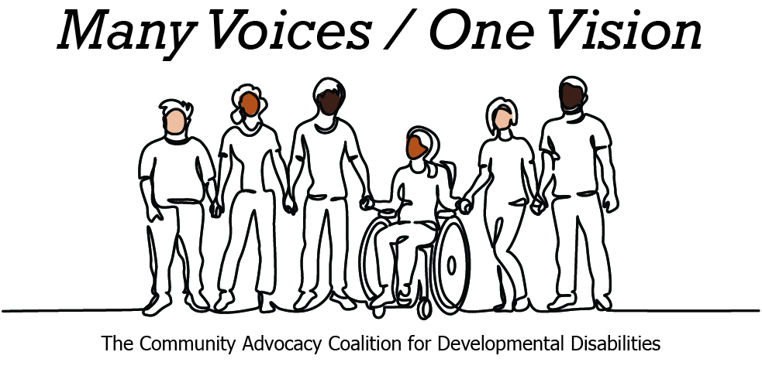 | 

2026 Legislative Candidate Survey
Questions for Legislative Candidates — The Arc of Washington
The Community Advocacy Coalition for Developmental Disabilities
The Children’s Campaign Fund

Name: Brian Burnett  Position: House  Legislative District: 12  Email: brian@burnettforstaterep.com  Website: https://burnettforstaterepresentative.com | 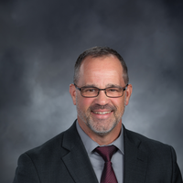

1. Do you have a personal connection or professional experience with someone who has an intellectual/developmental disability (IDD)?
If yes, would you describe its impact on you and your candidacy?
If not, what have you learned about people with intellectual or developmental disabilities and how has it impacted your candidacy?
I have a nephew who is autistic. In my 25 year career in law enforcement I was CIT certified and big supporter for the CIT program. I also witnessed many families struggling to find proper assistance and resources to navigate hard situations with their loved ones. Sitting on the Early Learning Human Services Committee, my awareness for the need for assistance and the importance of quality programing has catapulted me into a completely different perspective on this topic. My respect and adoration for the family members who have committed their lives in caring for their impacted love ones will never be stronger because of their testimony.
2. What policies and systems are you aware of that impact the lives of people with IDD and their families? If elected, what responsibility would you have to change those policies or systems?
I don't have anything specific but I know the topic for the closure of the Rainier School and moving people into smaller facilities (communities) is a very important topic as we need to be mindful that not every case, person or situation is alike, so we should be looking at diversifying programing as needed to serve all vulnerable people such as the IDD population.
3. If elected, what are your top three priorities, and how would people with IDD and their families benefit from each priority?
Community Safety (Protecting our most vulnerable population). This crosses over into early learning and human services as you consider victims of crimes, children and aging adults, but also abused and neglected foster children and of course our IDD population. As we know the budget will be a major stumbling block for many crucial and worthy programs, we need to fight for the services that we should truly be helping with for human services.
4. When you have questions about how to best support people with IDD and their families, what or who are your trusted resources?
Well the ARC of course is on the top of the list but I do have some local people within DHSH and Catholic Family Charities that I can go to for better direction when needed.
5. The national trend -- and legal mandate --- supports transitioning individuals with IDD out of institutional settings and into community-based care, which is not only the best practice but also the most cost-effective approach. Studies consistently show that community-based services cost significantly less per person than institutional care while providing greater independence and quality of life. In Washington the cost of care in a Residential Habilitation Center (RHC) is more than double the cost of equivalent services in community settings.
Although Washington has made progress, continued efforts are needed to align with best practices, civil rights, federal priorities, and fiscal responsibility. Transitioning more individuals into community-based care will allow the state to reinvest savings into services for much needed community-based services.
How do you believe Washington state should approach investment in home and community based services for people with IDD in the next five years?
No doubt that using our state funds wisely can lead to a better quality of life for the IDD population. I do think that the community based programming looks to be the future but we should still prepare and coordinate for the small population that doesn't fit that type of programming and living situations. So diversifying to fit the percentages and making the tax dollars maximize the impact to those being served and the quality of services.
6. Is there any other information you'd like constituents with intellectual or developmental disabilities and their family and friends to know?
Thank you for your commitment and steadfast dedication and love that you provide to those with IDD. You are and inspiration to me and challenge me to know more and do more for the IDD community members and those who support the IDD population to include family and professionals committed to the occupations that support IDD.

