Chapter 5

Into The Community

Support Objective: To provide families with the strategies, tools and courage to pursue their dreams.

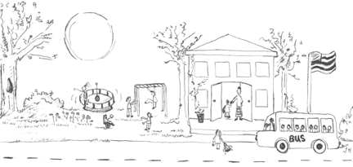

“What matters, we believe, is trying to be the best person you can and having people accept you for who you are, with all of your strengths and weaknesses. If we can accept people for who they are and not for who we want them to be, our communities will have moved a considerable distance.”
Jeff and Cindy Strully

The Circle of Friends

When a more intense and individualized facilitation strategy seems necessary, building a support circle for a student can be a means of helping students with and without disabilities develop friendships. Forest and Lusthaus describe the “circle of friends” as “a network that allows for the genuine involvement of children in a friendship, caring, and support role with their peers.” In order to be successful and lasting, the circle of friends concept must be used as an ongoing process. Forest cautions that “the Circles...technique may become routinized in schools and possibly detract from teachers’ and students’ efforts to develop more natural forms of support and friendship.”

Any relationships must be nurtured, supported and reinforced in order to flourish. Interpretation and accommodation may be necessary components at various stages in the process.

No matter the activity, constant adult presence poses a problem for students. Douglas Biklen states that a student can become “isolated from others in the class because he or she is constantly in the presence of a teaching aide.” He goes on to note that “an aide may unintentionally become a chaperone or the person’s only companion. Constant adult presence keeps peers from learning to communicate directly with the student and reinforces a perception that the student does not share interests or has needs similar to the other student’s.”

The friendship facilitation activities offered in this chapter are a small sampling of what is possible. When teams of educators and families come together with the common goal of supporting friendships and belonging for students with disabilities and for all students, the possibilities are limitless. Facilitation plans are most successful when they are customized for a particular student, his or her team of adults, and the school, family, and neighborhood community.

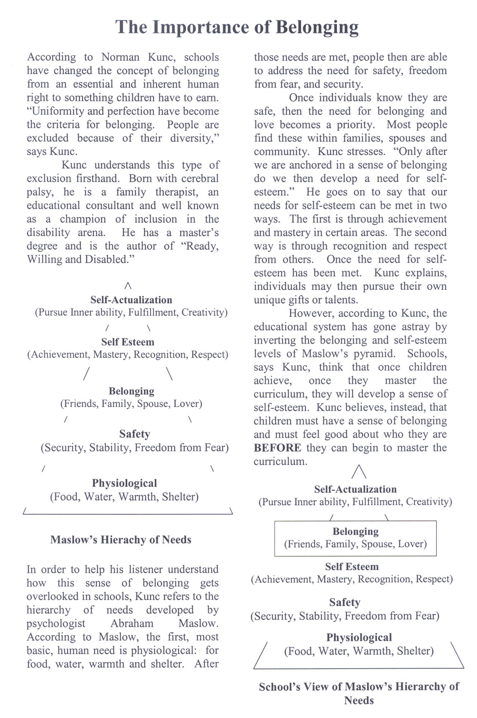

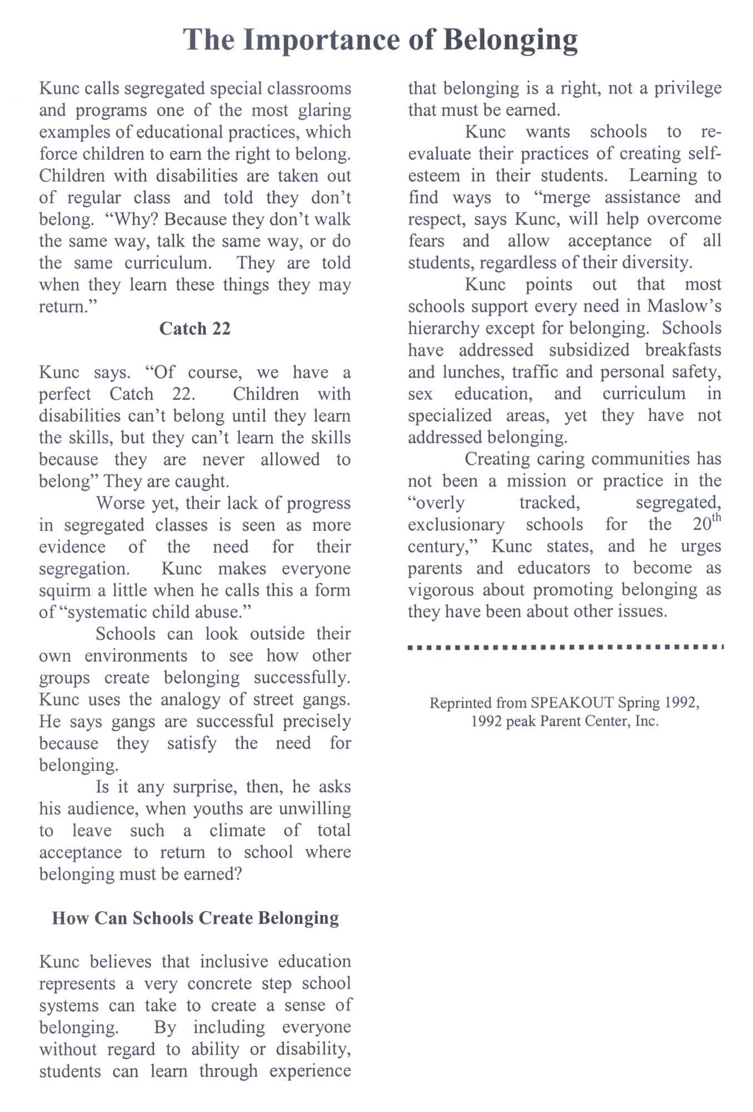

“We need to stop defining ‘normalcy’ in terms of perfection. Normalcy is not perfection; normalcy is diversity. I spent years trying to ‘fix’ my handicap and become ‘normal.’ Finally, the war between myself and my body came to an end. I realized I have the right to be handicapped. My disability represents the diversity of the human race.”

Norman Kunc

“I’m not sure that at any point we fully “accepted” Annie’s disability, although I remember clearly the day I quit viewing her disability as a separate entity. For years I had thought of it as a barrier between Annie and her world. Quite vividly, I saw that barrier disappear and become simply a part of who she was. There was relief in that. I was able to embrace Annie as a whole child, disability and all, and quit wishing part of her away.”

Annie’s Story
Vicki Isett

Dreams
by John Cox

It’s those last few months before your child is born that the dreams go into high gear. You imagine the engineer, ballerina or lawyer your child will grow up to be. As the delivery date draws near, these thoughts gather momentum, fed by parents, friends and co-workers, until you almost expect to see your child born 18 years old, highly educated and physically attractive.
It’s humbling how dreams that build up over so many years can blow away like so much air from a balloon. In the time it takes for a doctor to say, “Oh no” dreams can turn to nightmares and hopes to fears. Long-held thoughts of perfection melt away into short-term prayers and frantic thoughts: Will the baby be all right? What will we tell our parents? How did this happen? Why us? In a matter of moments, you have traded bar exams for brain scans, ballet shoes for blood tests, rock-solid normality for ground-breaking lunacy.
I watched helplessly as my baby was poked and prodded by strangers who did not have the time to answer my questions or allay my fears. I coped with a day-to-day roller coaster ride of good news, then bad; hopeful signs then puzzling questions. I found myself unable to dream, unable to see past the next doctor’s visit or test – each time hoping that someone would be able to determine what was wrong or what would happen in the future. Instead, my frustration deepened as each test revealed only the need for more. Worse still, no prognosis for the future was forthcoming – everyone finally said that only time would tell.
Very slowly, I realized that I would never know exactly what was going to happen until it did. At first, I was angry; I wanted answers. But it dawned on me one day that I was really no different than any other father. No doctor or specialist can tell any of us how bright or physically capable our children are going to be. The most that all parents can do is to make the best of what is given to us. This new realization liberated by wife and me. We began to look toward the future again, and started doing things that would give us and our child choices.
I began to dream again. These were not the same dreams as before, but they were just as important. I dreamed of my daughter’s first steps, and when they came, no parent was ever prouder. My wife and I dreamed of including her in a regular classroom at school, and after many battles, her first regular education teacher assured us that this was where she belonged.
I continue to dream of the future, of my daughter working, building meaningful relationships, and accomplishing great things for herself and others. I know that she will never be a lawyer, doctor or ballerina, yet I dream about what she can become, cherishing each step she takes along the way.
All children are a gift to their parents, grandparents, teachers and everyone who comes into contact with them. And they all teach us something that we would not have learned without them. For me, it was to slow down so I could take pleasure in the details of my children’s lives. I learned to take an active part in all my children’s activities and cherish each of their accomplishments. I am richer – for the experience of having a child with a disability. I would not wish it away.
A few years ago, I wondered what my daughter would have been like if she had not been born with a disability. I grieved for the loss of my “normal” life, somehow assuming that the one I had embarked on would not be as fulfilling. I don’t think that way anymore. I
am proud of my daughter’s accomplishments, and like any father, I am looking forward to future accomplishments as well. I should not have worried as much as I did. Looking back, I see now that few others have been as blessed as I.

“Dreams” by John Cox, is reprinted with the expressed consent and approval of Exceptional Parent, a monthly magazine for parents and families of children with disabilities and special health care needs. Submission cost is $24 per year for 12 issues. Call 1-800-247-8080. Offices at 120 State Street, Hackensack, New Jersey, 07601

INSTEAD

Instead of walking with you,
I will crawl with you.

Instead of talking with you,
I will find ways to communicate with you.

Instead of isolating you,
I will create adventures for you.

Instead of focusing on what you cannot do,
I will reward you with love for what you can do.

Instead of feeling sorry for you,
I will respect you.

________________________________________
Hogan Hilling, “A proud parent of a child with special needs.”
The Goose

One day, lying alone in the lawn on my back with only the drone
of a distant train on some far off track

I saw before my eyes, 5,000 feet high or more, a sight, which to this day, I must say, I’ve seen nothing like before.

The head goose, the leader of the “V,” suddenly veered out,
leaving a vacancy which was promptly filled by the bird behind.

The former leader then flew alongside, the formation continued growing wide, and he found a place at the back of the line.

They never missed a beat.

So, that’s how I found out how the goose can fly
from way up North to way down south and back again.

But he cannot do it alone, you see.
It’s something he can only do in the Community.

These days, it’s a popular notion and we swell with emotion and pride to think of ourselves on the eagle’s side

Solitary, Self-sufficient, Strong, but we are what we are, that’s
something we cannot choose.

And though many would wish to be seen as the eagle,
I think that we were made more like the goose.

(Stromberg, 1982)

The Slap

What do you do when reality slaps?
Slaps you so hard that your knees collapse

Do you run and hide until you feel
the warmth of the sun?

Do you stand and face it and
work until you’re done?

It’s a cycle that’s called Grief

What do you do to find Relief?

It’s a finishing line without an end
When you think you’re through
it slaps you again

You are not alone

Others too have been hit by this wave

Only with support I can stand and be brave

Knowing others have survived its wake

It’s the strength of the human heart
even when it breaks

- Michele Lehosky
P2P Coordinator
Pierce County

